**Pals**

Members: Cuello, Ajias, and Monteverde

**Overview:**

In the current digital age, smartphones have become essential tools for education, productivity, and convenience. With this shift, students and professionals now prefer tools that are quick, efficient, and easy to access all within the palm of their hand. One of the most sought-after categories of utility applications includes calculators, which help with mathematical, scientific, financial tasks and other everyday calculations.

Over time, mobile applications have evolved to offer specific calculators, such as unit converters, loan calculators, and scientific calculators, but users still face a fragmented experience when they need to switch between apps and websites for different functions. This is where our mobile application steps in. To unify various calculators into one platform, providing users with a seamless, efficient, and lightweight experience.

According to a study by Kim and Lee (2021), integrating multiple tools into one cohesive platform improves both usability and user retention. Another study by Santos et al. (2022) highlighted that users are more likely to engage with applications that offer intuitive navigation and centralized functionality. These studies validate the relevance of our multi-calculator app in providing practical value to everyday users, especially students and professionals who require accurate computations across different contexts.

Moreover, educational researchers such as Cruz & Mendoza (2020) emphasized that learning tools that are both accessible and interactive can greatly improve student comprehension and reduce cognitive load. With calculators designed to fit specific use cases such as number conversions, scientific calculations, financial planning and others, our app contributes to smoother academic and professional workflows.

**Solving the Problem:**

To address the challenges faced by users who need quick access to various calculators for different purposes, we developed a multi-calculator mobile application. This app allows users to easily switch between different tools such as number conversion and loan calculators within a single platform. By organizing each calculator into separate modules and loading them dynamically, the app reduces clutter and improves usability. It also ensures that students and professionals can find and use the specific calculator they need without having to download or switch between multiple apps. This streamlined solution saves time, enhances accessibility, and improves productivity for its users.

**The Application:**

● **Application name:** CalcBox

**● What it is:**

CalcBox is a modular, all-in-one calculator application that offers a wide range of mathematical tools from basic arithmetic to scientific and financial calculators and others. It is designed to be lightweight, accessible, and efficient for mobile devices.

**● Features:**

* **Basic Arithmetic Calculators** Perform standard operations: addition, subtraction, multiplication, and division.
* **Scientific Related Calculators**Supports trigonometric functions (sin, cos, tan), logarithmic functions (log, ln), constants like π and e, and parentheses for expression grouping.
* **Number System Conversions**Convert between binary, octal, decimal, and hexadecimal formats, useful for computer science and digital electronics.
* **Unit Conversions**Convert between different units for various categories, including:
  + **Length:** km - mi, m - ft, cm - in
  + **Weight:** kg - lbs, g - oz
  + **Temperature:** °C - °F - K
  + **Volume:** L - gal, mL - fl oz
  + And more (customizable for user needs)
* **Loan and Financial Calculator**Calculate monthly payments, interest, and total cost of loans using standard financial formulas.
* **Favorites System**  
  Users can mark calculators as favorites for quicker access, reducing time spent searching for frequently used tools.
* **Calculator Visibility Customization**Users can enable or disable specific calculators based on personal preferences, decluttering the interface.
* **"Last Used" Smart Launch**  
  On opening the app, CalcBox automatically loads the last calculator used, allowing users to resume their tasks instantly and show recently used
* **Responsive and Modular UI**Lightweight and modular architecture, where each calculator is loaded dynamically to improve performance and reduce initial app size.
* **Offline Support** All core functionality works without internet access.

**Questions about the Application:**

**○ Who are the potential users?**

The potential users of CalcBox include students, educators, professionals, and general users who require quick and reliable access to various types of calculators. Students from high school to college levels can benefit from the scientific and conversion features, while professionals in finance, engineering, and programming will find the specialized calculators, like loan and number system converters, particularly useful. Even casual users who need to convert units or perform basic arithmetic will find the app practical for everyday tasks.

**○ What tasks do they seek to perform?**

Users will use CalcBox to perform a wide range of mathematical and conversion-related tasks. These include basic arithmetic operations, scientific computations, unit conversions (such as kg to lbs or km to mi), number system translations, and financial calculations like loan estimates. Additionally, they may want to customize their experience by favoriting commonly used calculators or disabling others they don’t need. The ability to resume with the last used calculator also makes recurring tasks more efficient.

**○ What functionality should any system provide to these users?**

CalcBox should provide a modular and user-friendly interface where users can easily access and switch between different calculator types. It should support dynamic loading of calculators, personalization features like favorites and toggling calculator visibility, and persistence of the last used tool. The system should also work smoothly offline, be responsive across devices, and provide accurate, real-time results. Each calculator should be intuitive to use, clearly labeled, and optimized for both functionality and user experience.

**○ What constraints will be placed on your eventual design?**

Key constraints include ensuring the app performs well even with multiple calculators integrated, keeping the overall size of the app minimal by loading calculators dynamically, and maintaining a clean, navigable interface without overwhelming users. Compatibility across Android devices using Capacitor and the ability to run offline also shape design decisions. Additionally, since the app is expected to serve a broad audience, accessibility and clarity in design are important constraints.

**○ What criteria should be used to judge if your design is a success or not?**

The success of CalcBox can be judged by several criteria: user satisfaction and engagement (measured by usage frequency and feedback), performance and responsiveness of the app, ease of navigation and use, and the accuracy of each calculator’s functionality. A successful design should lead to reduced task time, minimal user frustration, and positive feedback about personalization features like favorites and the “last used” memory. Usability tests and surveys can further validate whether the app meets its intended goals effectively.

**Approach:**

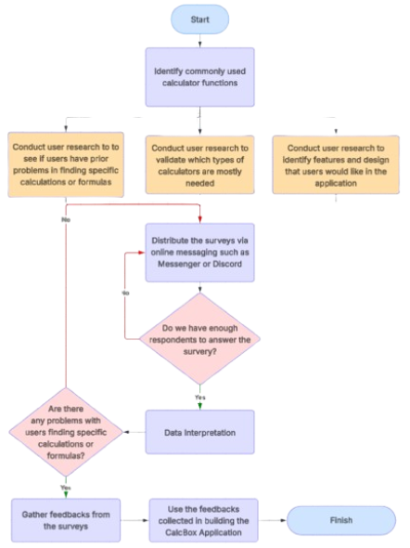

**Figure 1. Flowchart**